Let us run this on windows system and test for simplicity

Below is sample folder under F drive which has multiple file format extension

from GUI:



from cmd line and GUI there are multiple files with different ext and it looks very unstructured

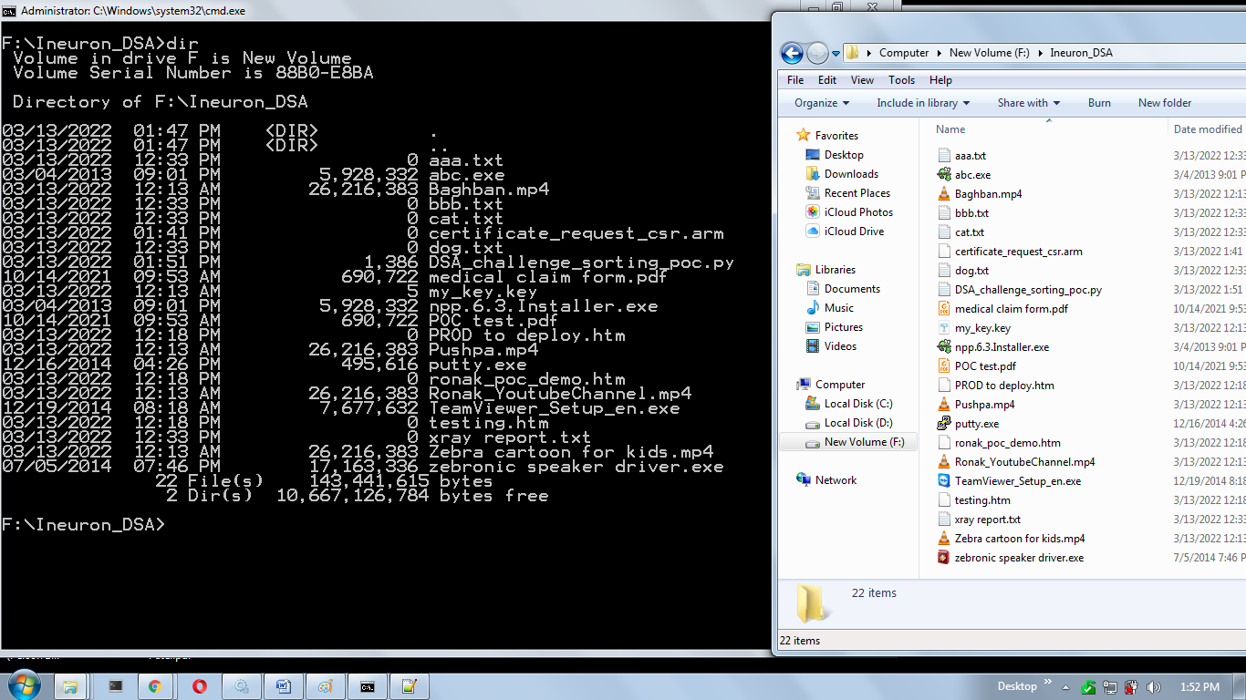

After running the code and entering the full folder path

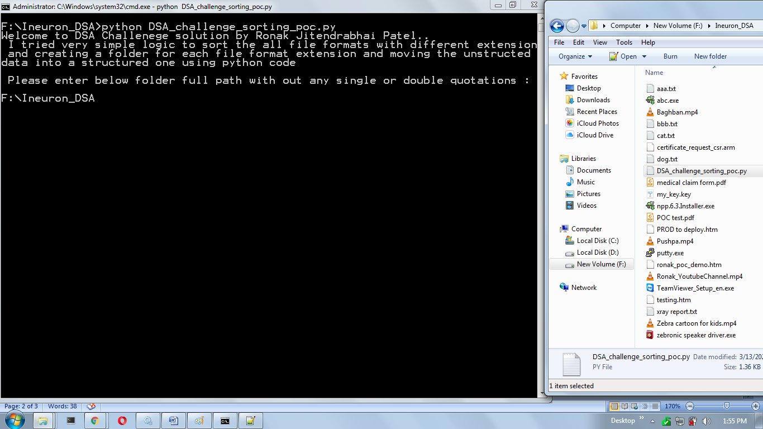

Now check the final results:

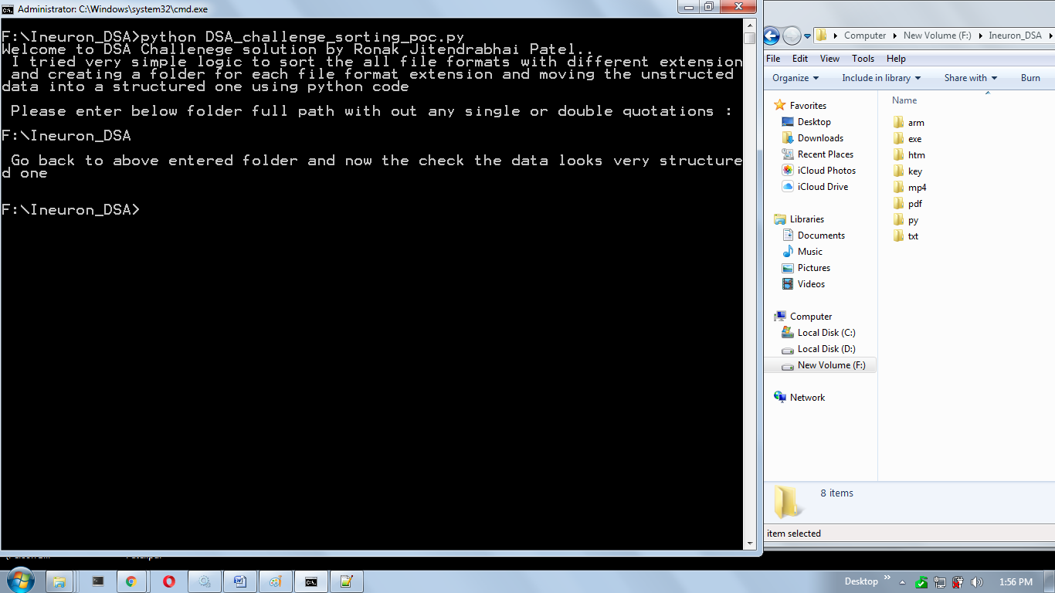

Folders are created based on extension name and the files are sorted and moved as per extension name into there respective folder:

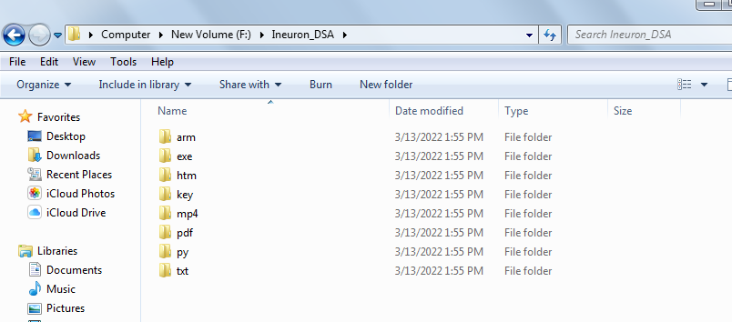

Now open all the above folders and see the files inside it in sorted form



